SET90103 Advanced Web Tech Report

Introduction
For this coursework, I chose to build a basic online music catalogue. It allows the user to search through an external sqlite3 database of songs, and pull back information about those songs, for example the artist or length of the track. The user can select to search by artist or song by selecting the appropriate radio button next to the search bar:
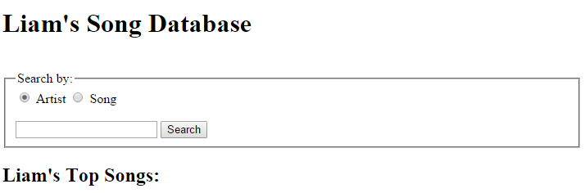

Design and Architecture
This website is simple and is based around a hierarchy of 3 URL addresses. The first of which is the “/” address. This is a URL that the user may initially navigate to, however it does not make very clear what the function of page does. Upon navigating to this URL, the user will be automatically redirected to the “/home” address.
The “/home” URL loads the home page of the music catalogue, using a rendered HTML template to present a search form and “Top Songs” list to the user. The search form, when used, directs to the search results page, sending the search method and query to that page by means of a HTML GET request.
The “/results” URL is responsible for retrieving and displaying the search results to the user. The search method and search query are passed into the URL as parameters, and so are visible to the user in the address bar:
These parameters are pulled down into the python code and are used to set the database columns and query term in the SQL WITH clause.

Enhancements
There are a few big enhancements that could be made to this online catalogue. The first of which could be an upgrade of both database and website to allow for the inclusion of albums. This would mean the user could search for albums as opposed to just for artists or songs. Also, when viewing or searching a song, the user can find out easily what album that song came from.
Another additional enhancement could be the ability for the user to add new songs or albums to the catalogue. This would be a powerful feature if there was to be a new song release for example.
Finally, the searching experience could be improved greatly by the addition of small options and features such as a search again button, or pagination.

Critical Evaluation
This catalogue is very basic. It only supports the logging of songs and artists, and this information is displayed in a very simple yet clear manner.
However, the ability for the user to search by a method of their choosing is a more advanced feature and makes the process of retrieving data from the catalogue so much quicker and easier. Additionally, the URL hierarchy is simple and clear for the user to understand. The displaying of the search terms within the search URL is a feature seen on many popular websites, so it made complete sense to include that feature on this online catalogue.

Personal Evaluation
I found this project extremely challenging but very interesting, fun and rewarding. The skills learned here are crucial for future tasks both in University and in my career. The big things I can take away from this is that I now have a good understanding of Python, a language I did not previously know. I found the many features of the Flask library to be very powerful, especially the ability to redirect the user and render HTML templates.
Additionally, I have learned how to utilise the power and control provided to me by a Linux web server. Although I found this workflow very confusing and difficult to understand at first, I grew to like it as I used it more and more.
I had several problems developing this catalogue, firstly with my Linux server corrupting itself and losing some data. Secondly, I had trouble with my python source file and vim, where I unfortunately ended up with more than one version of the same file, each of which at a different stage of development. I overcame these problems however after I revaluated how I was accessing and saving my python source files.

Resources
The only additional libraries used in this project was the Sqlite3 database library –
https://www.sqlite.org/

